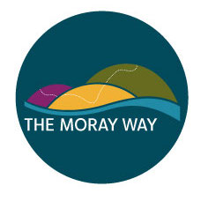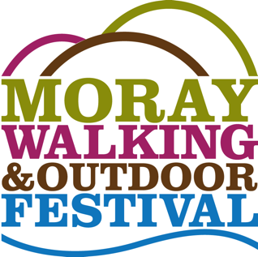
APPLICATION FOR MEMBERSHIP OF THE MORAY WAY ASSOCIATION
The Association’s objectives are:

- The provision of recreational facilities through maintenance, improvement and promotion of the Moray Way as a circular long-distance route, for the benefit and enjoyment of the Moray community and its visitors.
- The organisation of recreational activities promoting walking, cycling and other outdoor activities, through festivals and events, for the benefit and enjoyment of the Moray community and its visitors.
- The advancement of education through outdoor activities and events which develop skills and knowledge of participants; developing skills of volunteers; and provision of information to the public.

I would like to become a member of the Association.

Name (signature) ................................................................

Name (please print) ...........................................................

Address ............................................................................

..........................................................................................

........................................ Postcode ................................

Phone(s) ...........................................................................

e-mail ..........................................................................
(will not be distributed to any other party or organisation)

………. I support the objectives of the Association as described above.

Please post the completed form to the Secretary Moray Way Association, Town Hall, High Street, Forres, IV36 1PB

